WORK INTERGRATED LEARNING
XISD6329 - Task 1
Mobile Application and Website

Iziko Art Gallery Museum
Client: Iziko Museums of South Africa
Client Contact: Chief Educator of Art - Rory Emmett

Team
Group name: Core3 Systems
Group Members:
Rafiqah Kirby – ST10438554
Armalene Magerman – ST10454097
Chloe Langenhoven – ST10435895

Due date: 04 September 2026

Table of Contents
Table of Figures 3
Introduction 4
Project Plan 5
Project Schedules (Gantt Chart) 6
DevOps Lifecycle 6
Site Map 7
Team Members and Allocation 9
Wireframes 12
Website wireframe 12
Mobile Application Wireframes 13

Table of Figures

Figure 1: Project Plan -Milestone and Deliverable 5
Figure 2: Project Schedule Table 6
Figure 3: DevOps Lifecycle Diagram 6
Figure 4: Website Site Map 7
Figure 5: Mobile Application Site Map 8
Figure 6: Rafiqah CV 9
Figure 7: Armalene CV 10
Figure 8: Chloe CV 11
Figure 9: Website Wireframes (Screens 1-3) 12
Figure 10: Website Wireframes (Screens 4-6) 13

Introduction

This project is a continuation of the work completed in XISD5319 for the Iziko Museums of South Africa. In XISD5319, the focus was on research requirements and designing a proposed mobile application to make African art more accessible to people who cannot visit the museum in person.
XISD6329 builds on this previous work by continuing with the planning, development and improvement of the project. The project is being extended to include both a website and a mobile application. The research and prototype designs from XISD5319 will be used as the foundation. The team will update the project plan, create sitemaps and wireframes, develop the prototypes and use the DevOps lifecycle to manage the development process.
The main purpose of the project is to make it easier for people to explore and learn about African artwork using a mobile phone or computer. Users will be able to view artwork and learn about its history, culture and background from anywhere. The project is especially aimed at young people and international tourists, as the application can make learning about African art more interesting and encourage tourists to visit the museum.
The main goals are to:
- Display Iziko artwork on a mobile phone or computer.
- Provide information about the history and culture of each artwork.
- Create a simple and easy-to-use website and mobile application.
- Make African art accessible to people around the world.
- Encourage people to visit the museum in person.
- Use technology to promote and preserve African cultural heritage.
GitHub will be used for version control, with team members regularly committing and pushing their work. Testing will also be completed to find problems and make improvements before the final submission.
The project will be completed at a low cost by using resources already available to us as students. Some risks include technical problems, delays, limited experience and difficulties with testing users from other countries. Local users and tourists can be used for testing to collect feedback and improve the final solution.

GitHub Link: https://github.com/ST10438554-kirby/XISD6329_Iziko_Museum

Project Plan

The updated project plan provides a schedule of the activities required to complete XISD6329 Task 1. The activities are built on the previous XISD5319 project and include the development of the website and mobile application, creation of the sitemap and wireframes, GitHub version control, testing and final documentation. Deliverables have been allocated to the team members according to their roles and responsibilities.
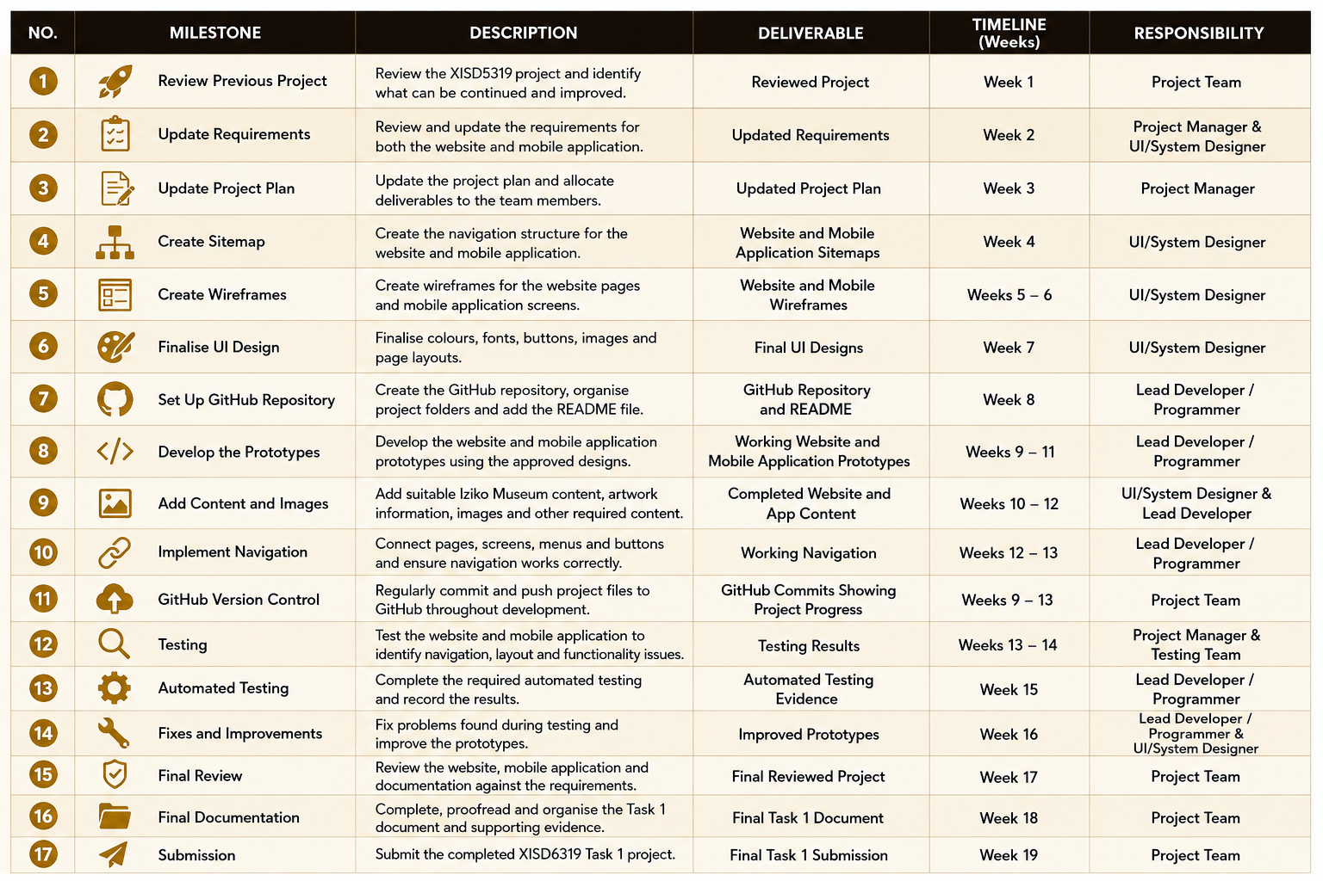
Figure 1: Project Plan -Milestone and Deliverable

Project Schedules (Gantt Chart)

The Gantt chart provides a visual representation of the project schedule. It shows when each activity will start and finish and how the activities overlap during the development period. The Gantt chart shows the planned sequence of activities from reviewing the previous project through to the final submission. The project begins with planning and requirements updates before moving into design activities such as the sitemap and wireframes. Development, content creation and GitHub version control take place during August. Testing and improvements are completed at the end of the development period, followed by final documentation.

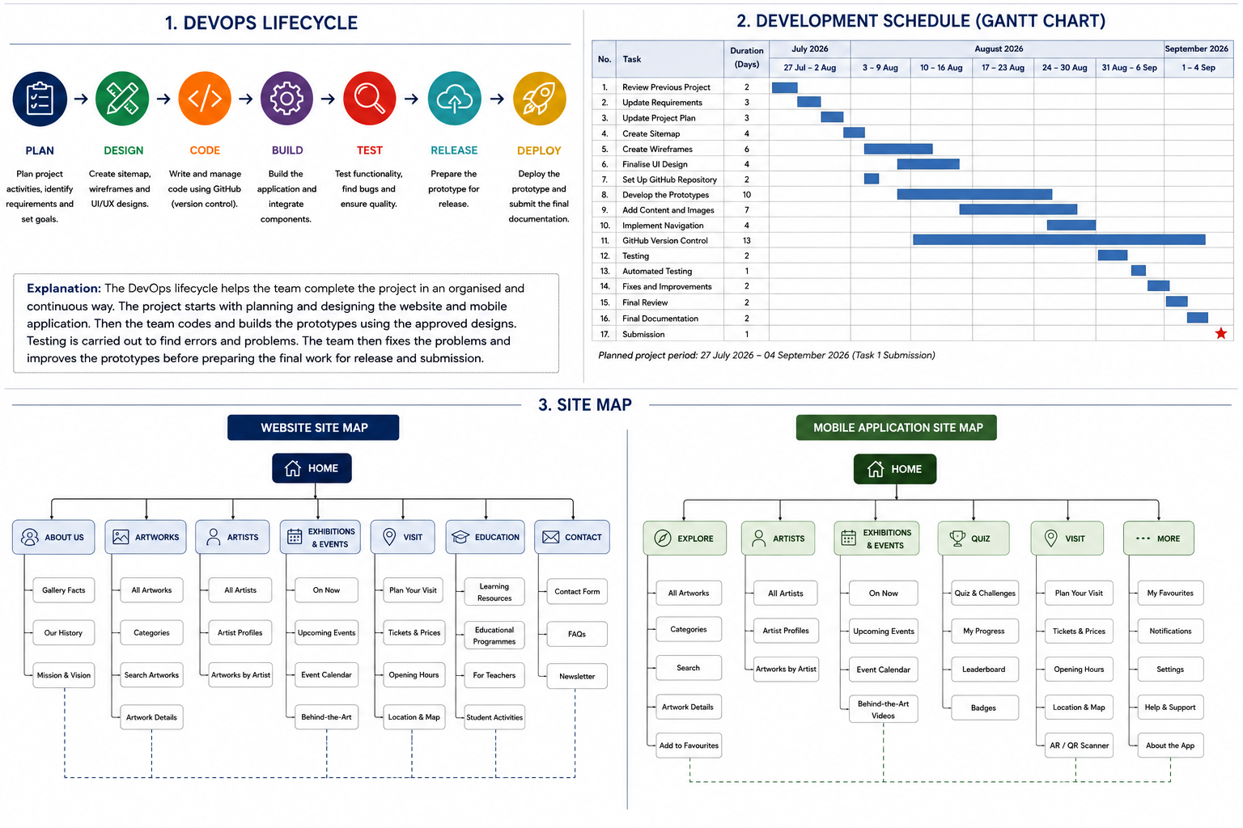
Figure 2: Project Schedule Table

DevOps Lifecycle

The DevOps lifecycle is used to organize the development process from the initial planning stage through to the final deployment of the project. It allows the team to work through the project in stages while continuously testing, improving and managing the project files. The project will follow a DevOps lifecycle to help the team plan, develop, test and improve the website and mobile application. The main stages used in this project are:
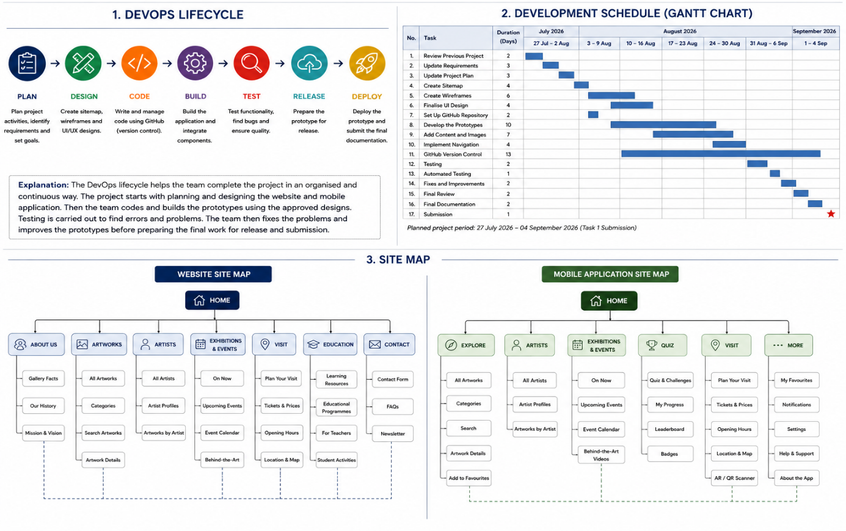

Figure 3: DevOps Lifecycle Diagram

The DevOps lifecycle will be used to guide the development of the Iziko Museum website and mobile application. The team will first plan the project and design the sitemap and wireframes. The development stage will then be used to build the website and mobile application. The project will be tested to identify and fix errors. After testing, improvements will be made before the final prototype and documentation are prepared for submission.

Site Maps

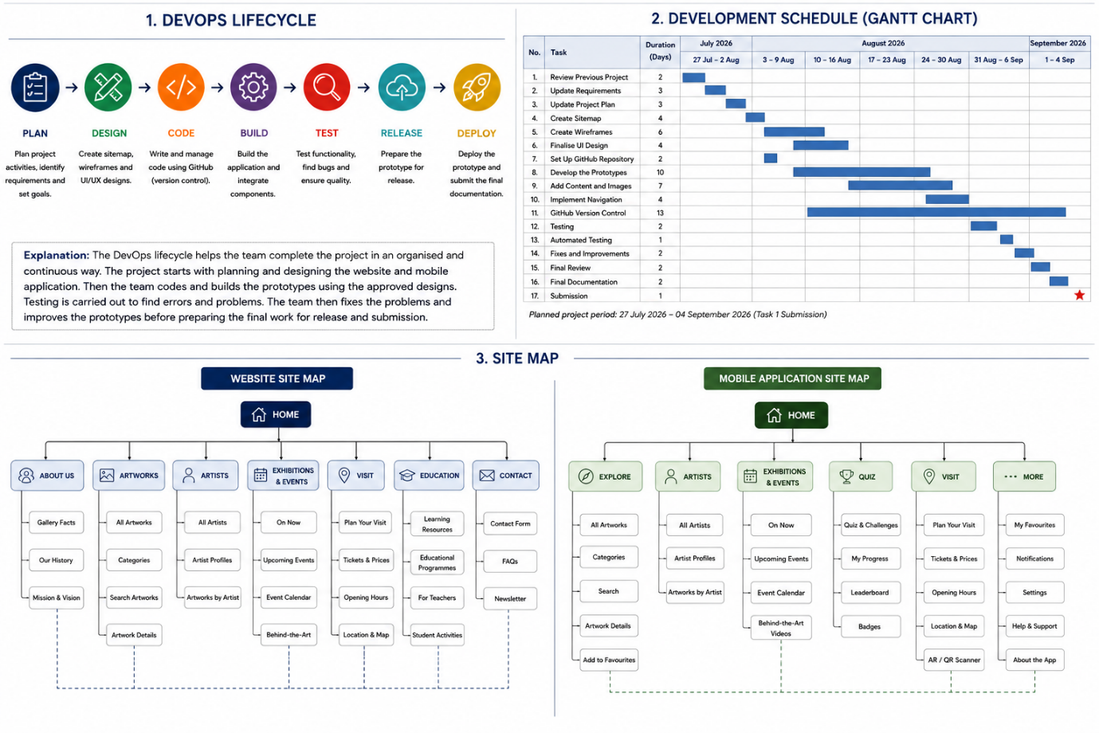
The sitemap shows the structure and navigation of the proposed Iziko South African National Gallery website and mobile application. It identifies the main sections of the system and the pages or screens that users can access from each section. Separate sitemaps are provided for the website and mobile application because the two platforms have different navigation requirements.
Figure 4: Website Site Map



Figure 5: Mobile Application Site Map

Team Members and Allocation

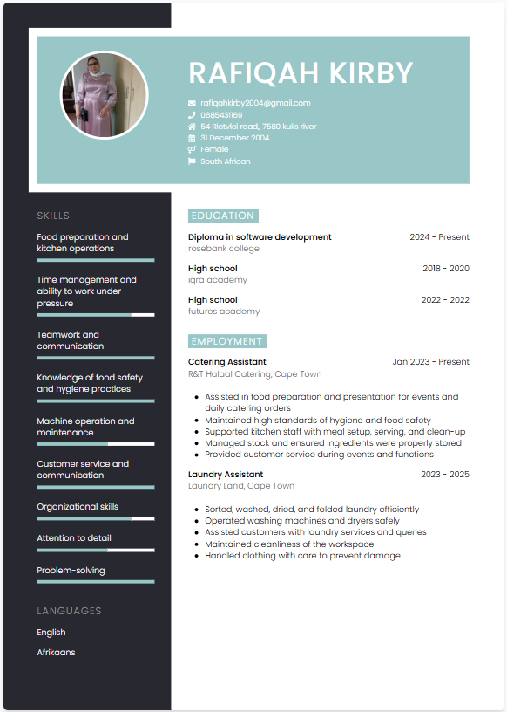
Team Leader
Role: Project Manager

Figure 6: Rafiqah CV

Responsibilities:
- Planning and coordinating all project activities
- Project tracking ensuring deadlines are met according to the Gantt chart
- Communicate with the client (Iziko Museums of South Africa)
- Oversee documentation and final submission
- Design user interface screens (Figma or similar tools)

Team Member
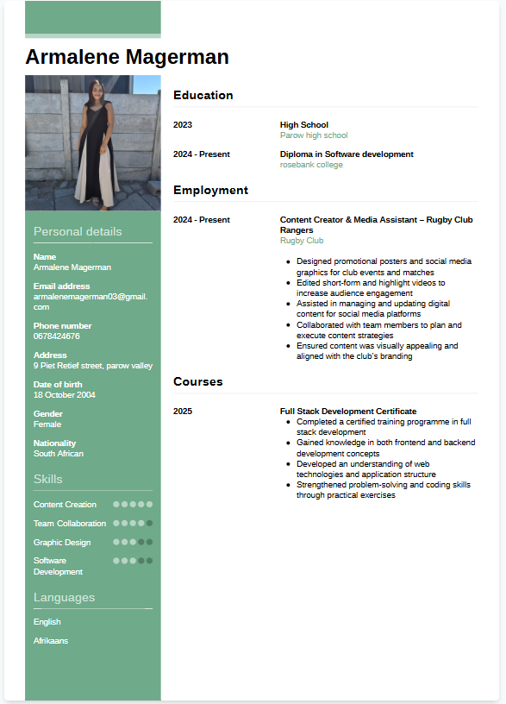
Role: Lead Developer / Programmer

Figure 7: Armalene CV

Responsibilities:
- Develop the mobile application using Kotlin/Android Studio
- Implement system features (gallery, videos, QR scanning, tracking)
- Perform testing and fix errors
- Assist with testing and deployment
- GitHub
- README
- Website development
- Functionality

Team Member
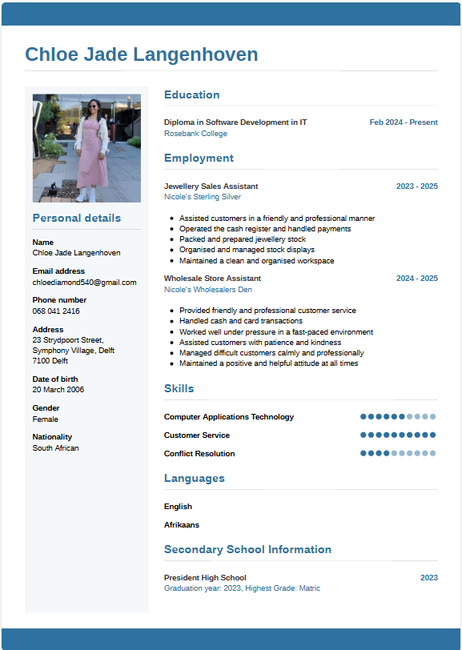
Role: System Designer / UI Designer

Figure 8: Chloe CV

Responsibilities:
- Ensure the system is user-friendly and visually appealing
- Assist with documentation related to page layouts
- Sitemap
- Wireframes
- UI design
- Visual content

Wireframes
The wireframes show the proposed layout and structure of the website and mobile application before the final development is completed. The designs are based on the existing Iziko South African National Gallery prototype developed from the previous project. The updated wireframes maintain a consistent visual identity while showing how the website and mobile application will provide users with access to artwork, artists, exhibitions, events and visitor information.

Website wireframe
The website wireframes are based on the existing Iziko South African National Gallery prototype. The Home page provides users with direct access to the main gallery functions. The Explore Artworks page allows users to search and filter artworks, while the Artists and Exhibitions & Events pages provide additional information about artists, exhibitions and programs. The Visit page provides practical information such as ticket prices, opening hours and location. The Virtual Museum Tour provides users with an online way to explore the gallery.
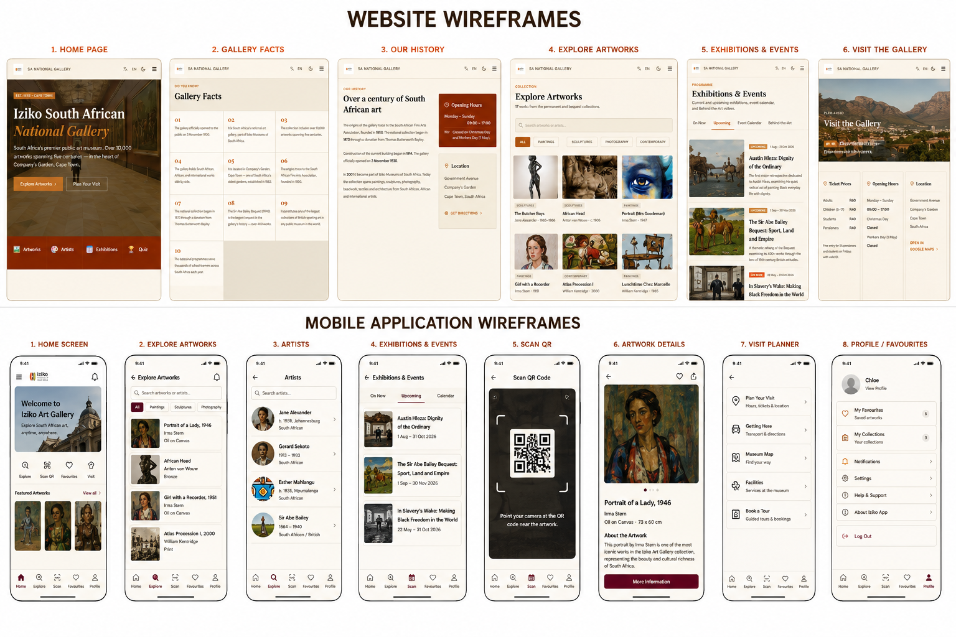

Figure 9: Website Wireframes (Screens 1-3)

Figure 10: Website Wireframes (Screens 4-6)

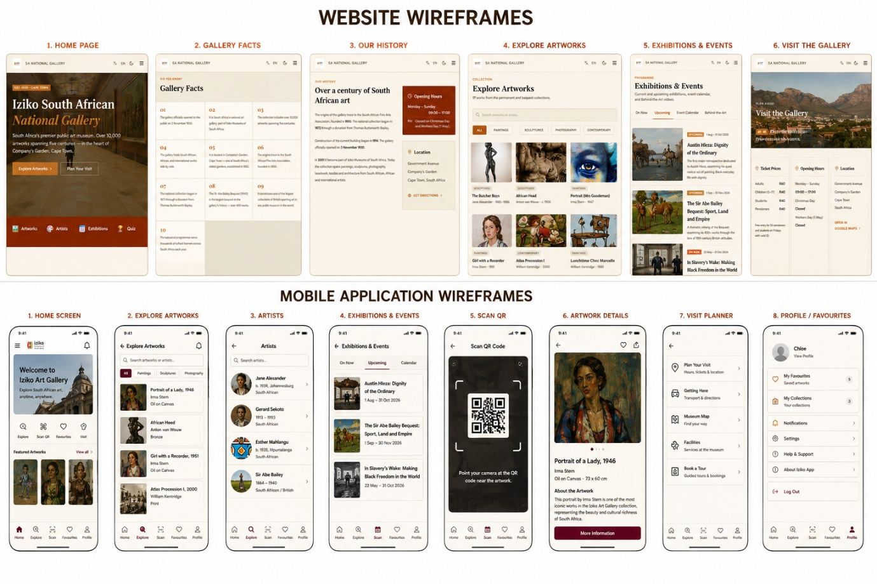
Mobile Application Wireframes
The mobile application wireframes adapt the existing Iziko prototype into a mobile-friendly layout. The screens provide simple navigation to important functions such as exploring artworks, viewing artists, checking exhibitions and events, completing quizzes and planning a visit.



The QR/AR feature also supports the interactive museum experience proposed in the previous project. The mobile wireframes are designed to keep the same visual identity as the website while making the interface suitable for smaller screens.

Figure 12: Mobile Application Wireframes

References

Elmasri, R. and Navathe, S.B. (2016) Fundamentals of Database Systems. 7th edn. Boston: Pearson.
Google (2026) Firebase Documentation. Available at: https://firebase.google.com/docs (Accessed: 29 August 2026).
Hoffer, J.A., George, J.F. and Valacich, J.S. (2016) Modern Systems Analysis and Design. 9th edn. Harlow: Pearson.
International Organization for Standardization (2018) ISO 31000: Risk management – Guidelines. Geneva: ISO.
Iziko Museums of South Africa (2026) Official website. Available at: https://www.iziko.org.za (Accessed: 26 August 2026).
Kendall, K.E. and Kendall, J.E. (2019) Systems Analysis and Design. 10th edn. Harlow: Pearson.
Kerzner, H. (2017) Project Management: A Systems Approach to Planning, Scheduling, and Controlling. 12th edn. Hoboken: Wiley.
Labour Guide (2026) National minimum wage increase effective 1 March 2026. Available at: https://labourguide.co.za/employment-condition/national-minimum-wage-increase-effective-1-march-2026 (Accessed: 20 August 2026).
Microsoft (2026) Azure DevOps documentation. Available at: https://learn.microsoft.com/en-us/azure/devops/ (Accessed: 1 September 2026).
Oracle (2026) MySQL Documentation. Available at: https://dev.mysql.com/doc/ (Accessed: 3 September 2026).
Pressman, R.S. and Maxim, B.R. (2019) Software Engineering: A Practitioner’s Approach. 9th edn. New York: McGraw-Hill Education.
Satzinger, J.W., Jackson, R.B. and Burd, S.D. (2016) Systems Analysis and Design in a Changing World. 7th edn. Boston: Cengage Learning.
Schwalbe, K. (2019) Information Technology Project Management. 9th edn. Boston: Cengage Learning.
Sommerville, I. (2016) Software Engineering. 10th edn. Boston: Pearson.

